Enhanced Delta Smelt Monitoring
  - 2025 Phase 1 Preliminary Analysis
  - U.S. Fish and Wildlife Service
  - March 28, 2025
DRAFT

Overview
The Enhanced Delta Smelt Monitoring (EDSM) program started its 2025 Phase 1 sampling program for adult Delta Smelt on December 2, 2024. Sampling effort is focused on geographic areas where Delta Smelt are likely to be caught based on historical data. Sampling locations are generated using a generalized random-tessellation stratified (GRTS) design (Stevens 2004) with stratification and equal probability sampling. Trawling gear similar to that used in the California Department of Fish and Wildlife’s Spring Kodiak Trawl Survey (https://www.wildlife.ca.gov/Conservation/Delta/Spring-Kodiak-Trawl) is used to conduct multiple tows per site.
Everything presented here is preliminary and subject to correction, revision, and improvement. The following points should be taken into consideration when interpreting the results:
- Abundance indices incorporate Delta Smelt regardless of origin, i.e. wild or hatchery.
- Delta Smelt captured outside of the live box or cod end of the net could not be assigned to a specific tow and were excluded from this analysis (see exception in Note section below). These fish are included in the daily catch summary and are indicated by a Gear Condition Code of 9. Delta Smelt captured in highly impaired samples, e.g., samples with large net blockages of debris or vegetation, were also excluded from this analysis. These fish are included in the daily catch summary and are indicated by a Gear Condition Code of 3.
- The ‘Week’ designations used here were defined out of convenience and are subject to change.
- Current sampling is limited to areas of the Bay-Delta that can be safely navigated by EDSM vessels, which means areas with a minimum depth of approximately 8 feet. The abundance estimation method used here assumes that the density of fish in unsampled areas (i.e., those with depth less than 8 feet) is the same as in sampled areas (i.e., those with depth greater than or equal to 8 feet).
- The methods of analysis used here remain in development.

Note
Report date December 16, 2024: Table 2 was updated to reflect the number of code-9 Delta Smelt caught. Code-9 fish are not used in the tow-level model.
Report date January 13, 2025: One of the two Delta Smelt caught in Suisun Marsh the week of January 6-10 was potentially a juvenile based on fork length (54 mm).
Report date January 17, 2025: The Western Delta stratum was added to the sampling frame on January 13, 2025.

Summary of Delta Smelt Releases
Further release information is available on the SacPAS Delta Smelt Release page (http://www.cbr.washington.edu/sacramento/workgroups/delta_smelt.html).
Table 1: Summary of Delta Smelt experimental releases for winter 2024 - 2025.
Release | Site | Date(s) | Total Released
1 | Lookout Slough near Shag Slough | November 18, 2024 | 13,573
2 | Lookout Slough near Shag Slough | December 9, 2024 | 14,880
3 | Sacramento River at Rio Vista | December 18, 2024 | 20,219
4 | Lookout Slough near Shag Slough | January 8, 2025 | 10,024
5 | Lookout Slough near Shag Slough | January 22, 2025 | 25,226
6 | Sacramento River at Rio Vista | January 27, 2025 | 24,504
7 | Sacramento River at Rio Vista | February 3, 2025 | 16,520

Methods
Delta Smelt abundance indices were derived from a negative binomial generalized linear mixed model with tow-level resolution containing (1) fixed effects for each week-stratum combination, (2) first and second order polynomial terms for the environmental variables Secchi depth, specific conductance, and water temperature, (3) site random effect, and (4) volume of water sampled in a tow as an offset. The model was fit with EDSM Kodiak trawl data collected between December 2016 and the present. Results presented here are limited to the current phase.

Results
Table 2: Delta Smelt catch summary and abundance indices by week. The total number of Delta Smelt, the number of marked Delta Smelt, and the number of code-9 Delta Smelt are indicated in separate columns. Lower Bound and Upper Bound represent a 95% confidence interval on the index point estimate. An asterisk (*) is used to emphasize weeks when no code-9 Delta Smelt were caught and NA is used to indicate that sampling did not occur or that a quantity could not be calculated. Weekly totals are only calculated when sampling has occurred in every stratum. Sample volumes are in cubic meters. See Table 3 for the dates corresponding to each week number.
Week | Stratum | Number of Sites | Number of Tows | Total Number Caught | Number Marked | Number of Code 9's | Total Sample Volume | Abundance Index | Lower Bound | Upper Bound
1 | Suisun Bay | 5 | 20 | 0 | 0 | 0 | 72,995 | 0* | NA | NA
1 | Suisun Marsh | 6 | 24 | 0 | 0 | 0 | 90,103 | 0* | NA | NA
1 | Lower Sacramento | 6 | 22 | 1 | 1 | 0 | 86,155 | 1,100 | 111 | 4,473
1 | Cache Slough LI | 3 | 12 | 0 | 0 | 0 | 41,412 | 0* | NA | NA
1 | Sac DW Ship Channel | 3 | 12 | 0 | 0 | 0 | 47,566 | 0* | NA | NA
1 | Lower San Joaquin | 5 | 20 | 0 | 0 | 0 | 70,029 | 0* | NA | NA
1 | Southern Delta | 5 | 18 | 0 | 0 | 0 | 61,909 | 0* | NA | NA
1 | All Strata | 33 | 128 | 1 | 1 | 0 | 470,169 | 1,100 | 111 | 4,473
2 | Suisun Bay | 3 | 12 | 0 | 0 | 0 | 47,831 | 0* | NA | NA
2 | Suisun Marsh | 3 | 12 | 0 | 0 | 0 | 59,756 | 0* | NA | NA
2 | Lower Sacramento | 1 | 4 | 0 | 0 | 0 | 14,739 | 0* | NA | NA
2 | Cache Slough LI | 3 | 12 | 1 | 1 | 1 | 48,302 | 0* | NA | NA
2 | Sac DW Ship Channel | 2 | 8 | 0 | 0 | 0 | 33,825 | 0* | NA | NA
2 | Lower San Joaquin | 6 | 24 | 0 | 0 | 0 | 90,488 | 0* | NA | NA
2 | Southern Delta | 3 | 12 | 0 | 0 | 0 | 47,060 | 0* | NA | NA
2 | All Strata | 21 | 84 | 1 | 1 | 1 | 342,001 | 0* | NA | NA
3 | Suisun Bay | 5 | 15 | 0 | 0 | 0 | 72,912 | 0* | NA | NA
3 | Suisun Marsh | 5 | 20 | 1 | 1 | 0 | 94,211 | 877 | 85 | 3,624
3 | Lower Sacramento | 6 | 20 | 4 | 4 | 0 | 79,338 | 4,717 | 901 | 14,829
3 | Cache Slough LI | 3 | 12 | 0 | 0 | 0 | 39,003 | 0* | NA | NA
3 | Sac DW Ship Channel | 3 | 12 | 0 | 0 | 0 | 42,153 | 0* | NA | NA
3 | Lower San Joaquin | 5 | 20 | 0 | 0 | 0 | 80,396 | 0* | NA | NA
3 | Southern Delta | 5 | 20 | 0 | 0 | 0 | 69,800 | 0* | NA | NA
3 | All Strata | 32 | 119 | 5 | 5 | 0 | 477,813 | 5,595 | 1,292 | 16,031
4 | Suisun Bay | 3 | 12 | 0 | 0 | 0 | 59,297 | 0* | NA | NA
4 | Suisun Marsh | 3 | 11 | 0 | 0 | 0 | 56,192 | 0* | NA | NA
4 | Lower Sacramento | 2 | 8 | 0 | 0 | 0 | 30,911 | 0* | NA | NA
4 | Cache Slough LI | 2 | 8 | 0 | 0 | 0 | 30,548 | 0* | NA | NA
4 | Sac DW Ship Channel | 2 | 8 | 0 | 0 | 0 | 29,480 | 0* | NA | NA
4 | Lower San Joaquin | 3 | 11 | 0 | 0 | 0 | 40,898 | 0* | NA | NA
4 | Southern Delta | 3 | 10 | 0 | 0 | 0 | 34,630 | 0* | NA | NA
4 | All Strata | 18 | 68 | 0 | 0 | 0 | 281,956 | 0* | NA | NA
5 | Suisun Bay | 6 | 21 | 2 | 2 | 0 | 109,543 | 6,626 | 1,046 | 22,677
5 | Suisun Marsh | 6 | 23 | 2 | 2 | 0 | 120,931 | 1,488 | 230 | 5,140
5 | Lower Sacramento | 6 | 23 | 1 | 1 | 0 | 83,318 | 1,256 | 130 | 5,072
5 | Cache Slough LI | 3 | 12 | 0 | 0 | 0 | 45,763 | 0* | NA | NA
5 | Sac DW Ship Channel | 3 | 12 | 0 | 0 | 0 | 46,642 | 0* | NA | NA
5 | Lower San Joaquin | 6 | 22 | 1 | 1 | 0 | 81,153 | 1,957 | 208 | 7,818
5 | Southern Delta | 5 | 18 | 0 | 0 | 0 | 66,790 | 0* | NA | NA
5 | All Strata | 35 | 131 | 6 | 6 | 0 | 554,141 | 11,328 | 3,254 | 28,907
6 | Suisun Bay | 4 | 16 | 0 | 0 | 0 | 83,032 | 0* | NA | NA
6 | Suisun Marsh | 6 | 24 | 2 | 2 | 0 | 120,712 | 1,547 | 243 | 5,307
6 | Lower Sacramento | 5 | 19 | 1 | 1 | 0 | 75,407 | 1,519 | 156 | 6,154
6 | Cache Slough LI | 3 | 12 | 0 | 0 | 0 | 45,354 | 0* | NA | NA
6 | Sac DW Ship Channel | 3 | 12 | 0 | 0 | 0 | 46,115 | 0* | NA | NA
6 | Lower San Joaquin | 6 | 22 | 0 | 0 | 0 | 88,059 | 0* | NA | NA
6 | Southern Delta | 3 | 12 | 0 | 0 | 0 | 49,234 | 0* | NA | NA
6 | All Strata | 30 | 117 | 3 | 3 | 0 | 507,912 | 3,067 | 661 | 9,099
7 | Western Delta | 3 | 12 | 0 | 0 | 0 | 68,701 | 0* | NA | NA
7 | Suisun Bay | 6 | 24 | 0 | 0 | 0 | 123,426 | 0* | NA | NA
7 | Suisun Marsh | 3 | 11 | 1 | 1 | 0 | 55,200 | 1,562 | 128 | 6,821
7 | Lower Sacramento | 6 | 23 | 2 | 2 | 0 | 92,815 | 2,239 | 348 | 7,714
7 | Cache Slough LI | 3 | 12 | 1 | 1 | 0 | 46,088 | 656 | 51 | 2,914
7 | Sac DW Ship Channel | 3 | 12 | 0 | 0 | 0 | 45,472 | 0* | NA | NA
7 | Lower San Joaquin | 6 | 22 | 1 | 1 | 0 | 84,385 | 1,744 | 179 | 7,053
7 | Southern Delta | 5 | 18 | 0 | 0 | 0 | 67,605 | 0* | NA | NA
7 | All Strata | 35 | 134 | 5 | 5 | 0 | 583,692 | 6,200 | 1,793 | 15,764
8 | Western Delta | 4 | 14 | 0 | 0 | 0 | 64,719 | 0* | NA | NA
8 | Suisun Bay | 6 | 24 | 0 | 0 | 0 | 116,924 | 0* | NA | NA
8 | Suisun Marsh | 3 | 10 | 1 | 1 | 0 | 50,099 | 2,237 | 202 | 9,464
8 | Lower Sacramento | 6 | 24 | 0 | 0 | 0 | 98,418 | 0* | NA | NA
8 | Cache Slough LI | 3 | 10 | 2 | 2 | 0 | 39,354 | 1,778 | 201 | 6,948
8 | Sac DW Ship Channel | 3 | 12 | 1 | 1 | 0 | 46,447 | 466 | 32 | 2,148
8 | Lower San Joaquin | 6 | 24 | 0 | 0 | 0 | 93,503 | 0* | NA | NA
8 | Southern Delta | 5 | 20 | 0 | 0 | 0 | 76,565 | 0* | NA | NA
8 | All Strata | 36 | 138 | 4 | 4 | 0 | 586,028 | 4,481 | 895 | 13,786
9 | Western Delta | 4 | 16 | 0 | 0 | 0 | 84,626 | 0* | NA | NA
9 | Suisun Bay | 4 | 16 | 0 | 0 | 0 | 81,262 | 0* | NA | NA
9 | Suisun Marsh | 3 | 12 | 0 | 0 | 0 | 62,523 | 0* | NA | NA
9 | Lower Sacramento | 6 | 21 | 1 | 1 | 0 | 85,727 | 804 | 75 | 3,355
9 | Cache Slough LI | 3 | 12 | 0 | 0 | 0 | 45,160 | 0* | NA | NA
9 | Sac DW Ship Channel | 3 | 12 | 1 | 1 | 0 | 46,663 | 413 | 30 | 1,880
9 | Lower San Joaquin | 6 | 23 | 0 | 0 | 0 | 92,789 | 0* | NA | NA
9 | Southern Delta | 5 | 20 | 0 | 0 | 0 | 74,491 | 0* | NA | NA
9 | All Strata | 34 | 132 | 2 | 2 | 0 | 573,241 | 1,217 | 181 | 4,271
10 | Western Delta | 2 | 3 | 0 | 0 | 0 | 15,616 | 0* | NA | NA
10 | Suisun Bay | 5 | 17 | 3 | 3 | 0 | 87,022 | 12,853 | 2,251 | 42,028
10 | Suisun Marsh | 3 | 8 | 2 | 2 | 0 | 39,169 | 5,416 | 647 | 20,736
10 | Lower Sacramento | 6 | 23 | 2 | 2 | 0 | 96,304 | 1,995 | 295 | 7,019
10 | Cache Slough LI | 3 | 12 | 0 | 0 | 0 | 40,993 | 0* | NA | NA
10 | Sac DW Ship Channel | 3 | 10 | 1 | 1 | 0 | 39,237 | 1,129 | 101 | 4,788
10 | Lower San Joaquin | 5 | 18 | 0 | 0 | 0 | 65,952 | 0* | NA | NA
10 | Southern Delta | 5 | 19 | 0 | 0 | 0 | 66,940 | 0* | NA | NA
10 | All Strata | 32 | 110 | 8 | 8 | 0 | 451,233 | 21,393 | 6,207 | 54,292
11 | Western Delta | 3 | 12 | 0 | 0 | 0 | 64,305 | 0* | NA | NA
11 | Suisun Bay | 4 | 14 | 0 | 0 | 0 | 74,153 | 0* | NA | NA
11 | Suisun Marsh | 3 | 6 | 12 | 12 | 0 | 23,042 | 51,758 | 9,013 | 169,663
11 | Lower Sacramento | 6 | 22 | 2 | 2 | 0 | 98,854 | 1,945 | 285 | 6,871
11 | Cache Slough LI | 3 | 10 | 1 | 1 | 0 | 36,631 | 1,300 | 116 | 5,514
11 | Sac DW Ship Channel | 4 | 13 | 1 | 1 | 0 | 50,128 | 482 | 38 | 2,131
11 | Lower San Joaquin | 5 | 17 | 2 | 2 | 0 | 67,068 | 4,435 | 645 | 15,712
11 | Southern Delta | 5 | 19 | 0 | 0 | 0 | 69,019 | 0* | NA | NA
11 | All Strata | 33 | 113 | 18 | 18 | 0 | 483,200 | 59,920 | 12,854 | 178,145
12 | Western Delta | 0 | 0 | 0 | 0 | 0 | 0 | NA | NA | NA
12 | Suisun Bay | 4 | 16 | 1 | 1 | 0 | 61,418 | 5,903 | 567 | 24,442
12 | Suisun Marsh | 3 | 10 | 1 | 1 | 0 | 38,453 | 2,720 | 238 | 11,615
12 | Lower Sacramento | 3 | 12 | 0 | 0 | 0 | 48,452 | 0* | NA | NA
12 | Cache Slough LI | 3 | 10 | 0 | 0 | 0 | 41,973 | 0* | NA | NA
12 | Sac DW Ship Channel | 3 | 11 | 1 | 1 | 0 | 49,678 | 812 | 72 | 3,447
12 | Lower San Joaquin | 6 | 23 | 2 | 2 | 0 | 90,280 | 3,051 | 465 | 10,599
12 | Southern Delta | 3 | 12 | 0 | 0 | 0 | 44,452 | 0* | NA | NA
12 | All Strata | 25 | 94 | 5 | 5 | 0 | 374,706 | 12,486 | 3,018 | 34,958
13 | Western Delta | 3 | 12 | 0 | 0 | 0 | 43,176 | 0* | NA | NA
13 | Suisun Bay | 6 | 24 | 0 | 0 | 0 | 89,381 | 0* | NA | NA
13 | Suisun Marsh | 3 | 12 | 0 | 0 | 0 | 43,768 | 0* | NA | NA
13 | Lower Sacramento | 5 | 20 | 0 | 0 | 0 | 72,937 | 0* | NA | NA
13 | Cache Slough LI | 3 | 12 | 0 | 0 | 0 | 42,491 | 0* | NA | NA
13 | Sac DW Ship Channel | 3 | 11 | 1 | 1 | 0 | 39,169 | 894 | 74 | 3,887
13 | Lower San Joaquin | 6 | 24 | 0 | 0 | 0 | 87,062 | 0* | NA | NA
13 | Southern Delta | 5 | 20 | 0 | 0 | 0 | 72,166 | 0* | NA | NA
13 | All Strata | 34 | 135 | 1 | 1 | 0 | 490,149 | 894 | 74 | 3,887
14 | Western Delta | 3 | 10 | 0 | 0 | 0 | 53,824 | 0* | NA | NA
14 | Suisun Bay | 6 | 24 | 0 | 0 | 0 | 127,267 | 0* | NA | NA
14 | Suisun Marsh | 3 | 12 | 0 | 0 | 0 | 57,878 | 0* | NA | NA
14 | Lower Sacramento | 6 | 24 | 0 | 0 | 0 | 98,012 | 0* | NA | NA
14 | Cache Slough LI | 3 | 12 | 0 | 0 | 0 | 44,050 | 0* | NA | NA
14 | Sac DW Ship Channel | 3 | 10 | 1 | 1 | 0 | 36,462 | 815 | 64 | 3,611
14 | Lower San Joaquin | 6 | 24 | 0 | 0 | 0 | 87,983 | 0* | NA | NA
14 | Southern Delta | 5 | 20 | 0 | 0 | 0 | 72,723 | 0* | NA | NA
14 | All Strata | 35 | 136 | 1 | 1 | 0 | 578,200 | 815 | 64 | 3,611
15 | Western Delta | 3 | 12 | 0 | 0 | 0 | 51,675 | 0* | NA | NA
15 | Suisun Bay | 6 | 24 | 0 | 0 | 0 | 103,275 | 0* | NA | NA
15 | Suisun Marsh | 3 | 12 | 2 | 2 | 0 | 49,241 | 3,478 | 401 | 13,497
15 | Lower Sacramento | 6 | 22 | 0 | 0 | 0 | 86,237 | 0* | NA | NA
15 | Cache Slough LI | 3 | 11 | 0 | 0 | 0 | 29,570 | 0* | NA | NA
15 | Sac DW Ship Channel | 1 | 4 | 0 | 0 | 0 | 18,399 | 0* | NA | NA
15 | Lower San Joaquin | 5 | 17 | 0 | 0 | 0 | 68,328 | 0* | NA | NA
15 | Southern Delta | 5 | 20 | 0 | 0 | 0 | 74,986 | 0* | NA | NA
15 | All Strata | 32 | 122 | 2 | 2 | 0 | 481,710 | 3,478 | 401 | 13,497
16 | Western Delta | 2 | 8 | 0 | 0 | 0 | 39,641 | 0* | NA | NA
16 | Suisun Bay | 6 | 24 | 0 | 0 | 0 | 114,227 | 0* | NA | NA
16 | Suisun Marsh | 3 | 12 | 0 | 0 | 0 | 43,712 | 0* | NA | NA
16 | Lower Sacramento | 6 | 24 | 0 | 0 | 0 | 94,777 | 0* | NA | NA
16 | Cache Slough LI | 3 | 12 | 0 | 0 | 0 | 47,822 | 0* | NA | NA
16 | Sac DW Ship Channel | 3 | 10 | 1 | 1 | 0 | 36,567 | 851 | 70 | 3,715
16 | Lower San Joaquin | 6 | 24 | 0 | 0 | 0 | 90,519 | 0* | NA | NA
16 | Southern Delta | 5 | 20 | 0 | 0 | 0 | 73,448 | 0* | NA | NA
16 | All Strata | 34 | 134 | 1 | 1 | 0 | 540,713 | 851 | 70 | 3,715
17 | Western Delta | 0 | 0 | 0 | 0 | 0 | 0 | NA | NA | NA
17 | Suisun Bay | 6 | 24 | 0 | 0 | 0 | 98,138 | 0* | NA | NA
17 | Suisun Marsh | 3 | 12 | 0 | 0 | 0 | 46,144 | 0* | NA | NA
17 | Lower Sacramento | 6 | 24 | 0 | 0 | 0 | 84,781 | 0* | NA | NA
17 | Cache Slough LI | 3 | 12 | 0 | 0 | 0 | 42,154 | 0* | NA | NA
17 | Sac DW Ship Channel | 3 | 12 | 0 | 0 | 0 | 47,142 | 0* | NA | NA
17 | Lower San Joaquin | 7 | 25 | 0 | 0 | 0 | 89,208 | 0* | NA | NA
17 | Southern Delta | 5 | 20 | 0 | 0 | 0 | 67,632 | 0* | NA | NA
17 | All Strata | 33 | 129 | 0 | 0 | 0 | 475,199 | 0* | NA | NA
Table 3: Week numbers and corresponding dates used in Table 2.
Week | Dates
1 | December 2–6, 2024
2 | December 9–13, 2024
3 | December 16–20, 2024
4 | December 23–27, 2024
5 | December 30, 2024–January 3, 2025
6 | January 6–10, 2025
7 | January 13–17, 2025
8 | January 20–24, 2025
9 | January 27–31, 2025
10 | February 3–7, 2025
11 | February 10–14, 2025
12 | February 17–21, 2025
13 | February 24–28, 2025
14 | March 3–7, 2025
15 | March 10–14, 2025
16 | March 17–21, 2025
17 | March 24–28, 2025

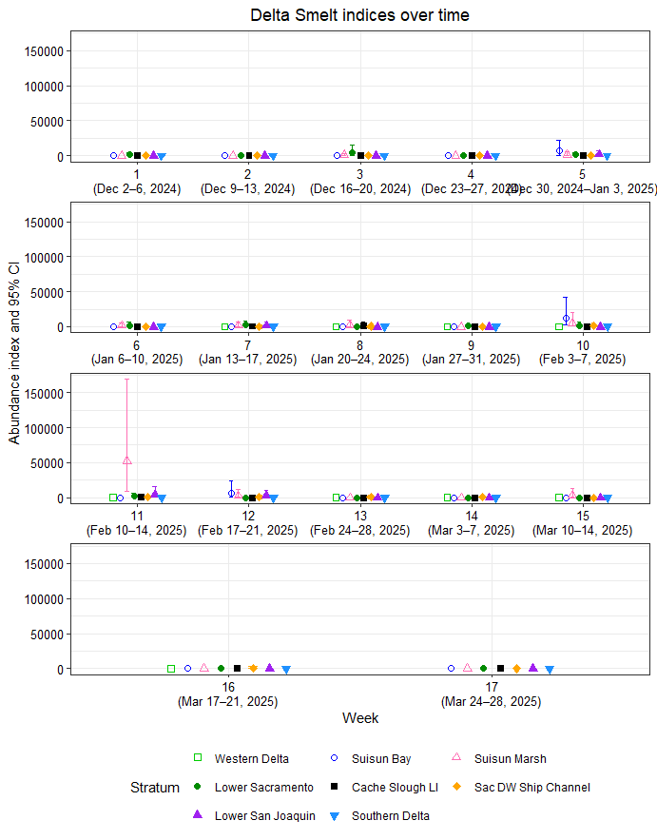
Figure 1: Delta Smelt abundance indices and 95% confidence intervals by week and stratum.

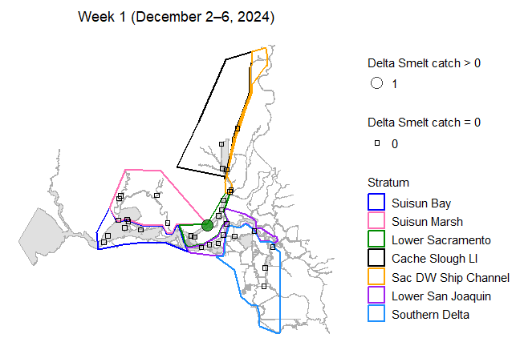
Figure 2: Map of total Delta Smelt catch by site in week 1.
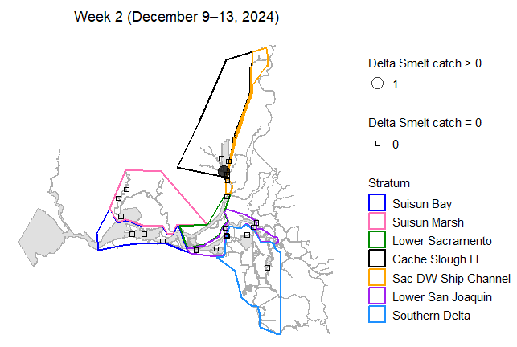
Figure 3: Map of total Delta Smelt catch by site in week 2.
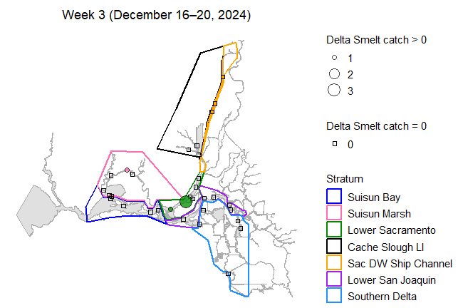
Figure 4: Map of total Delta Smelt catch by site in week 3.
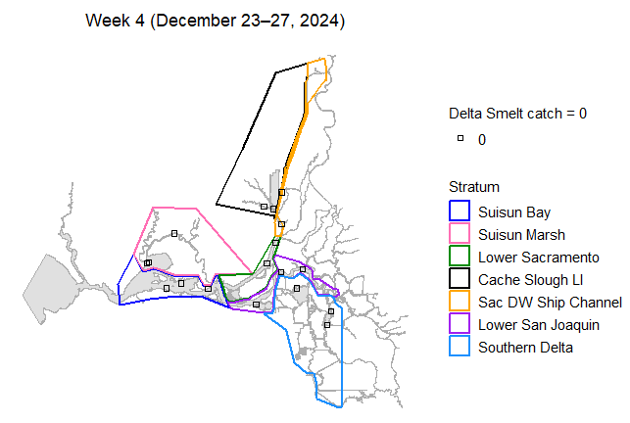
Figure 5: Map of total Delta Smelt catch by site in week 4.
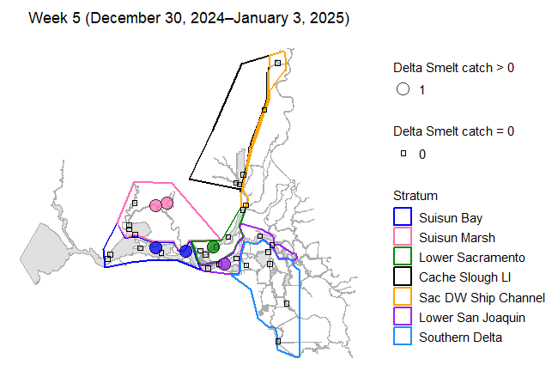
Figure 6: Map of total Delta Smelt catch by site in week 5.
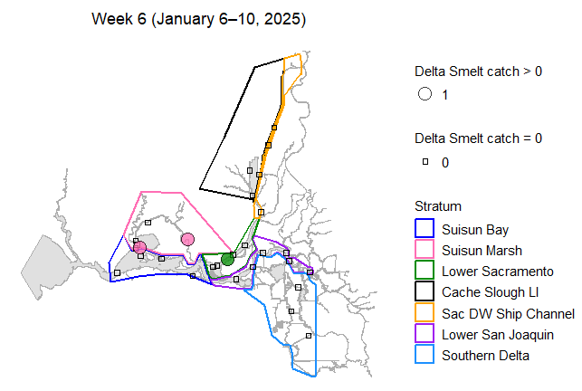
Figure 7: Map of total Delta Smelt catch by site in week 6.
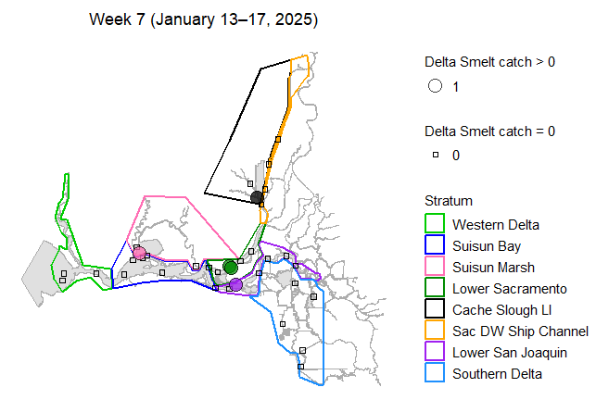
Figure 8: Map of total Delta Smelt catch by site in week 7.
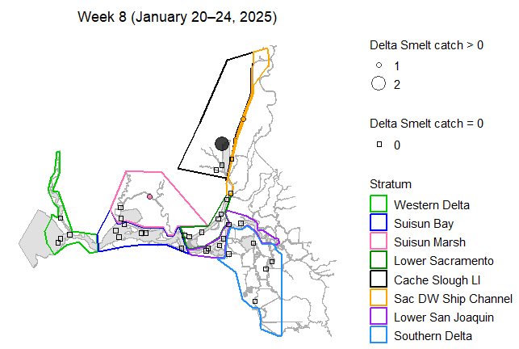
Figure 9: Map of total Delta Smelt catch by site in week 8.
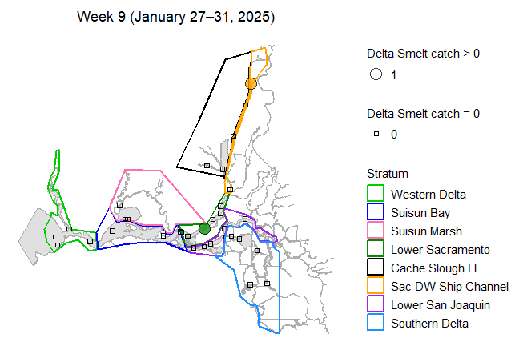
Figure 10: Map of total Delta Smelt catch by site in week 9.
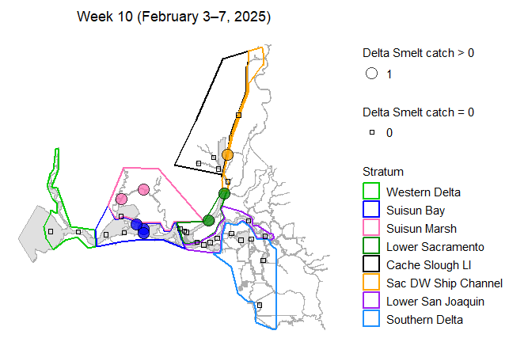
Figure 11: Map of total Delta Smelt catch by site in week 10.
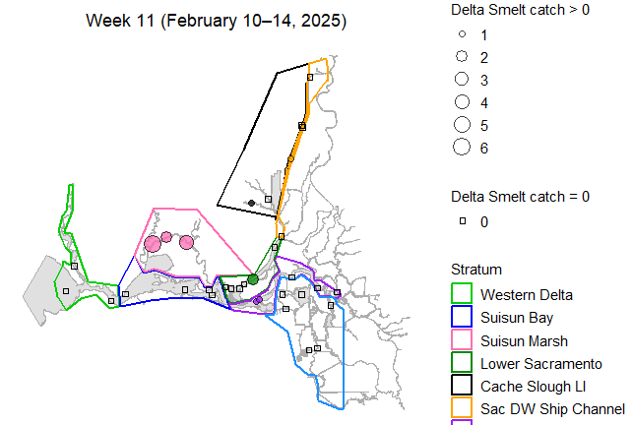
Figure 12: Map of total Delta Smelt catch by site in week 11.
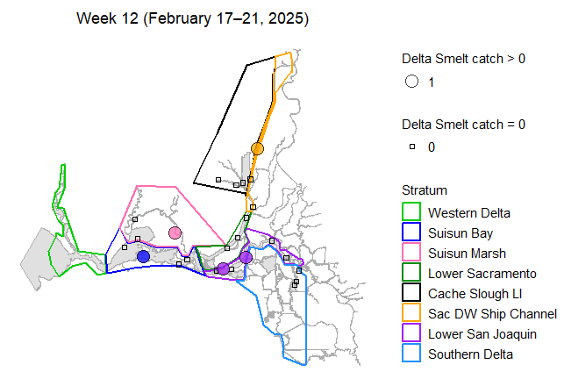
Figure 13: Map of total Delta Smelt catch by site in week 12.
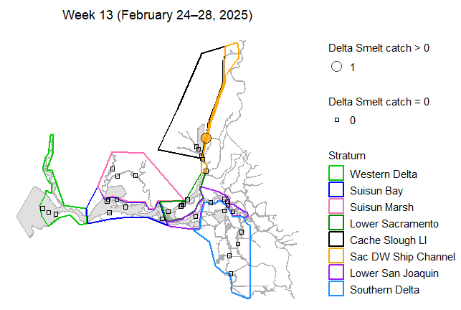
Figure 14: Map of total Delta Smelt catch by site in week 13.
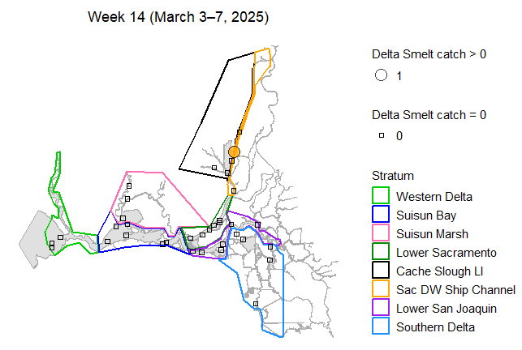
Figure 15: Map of total Delta Smelt catch by site in week 14.
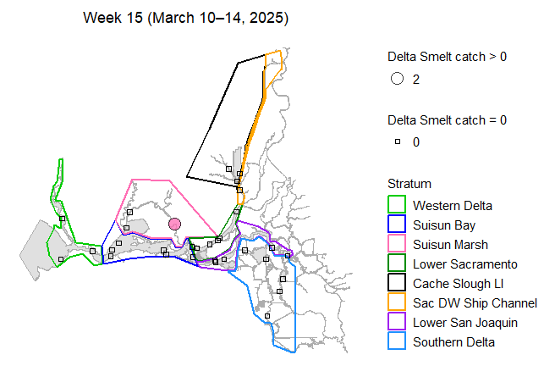
Figure 16: Map of total Delta Smelt catch by site in week 15.
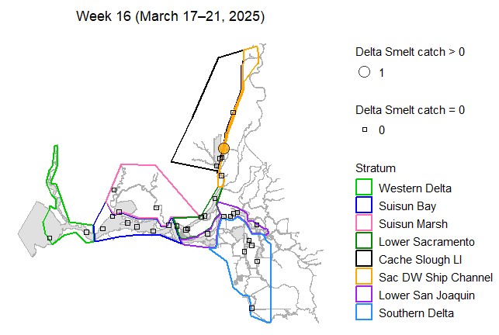
Figure 17: Map of total Delta Smelt catch by site in week 16.
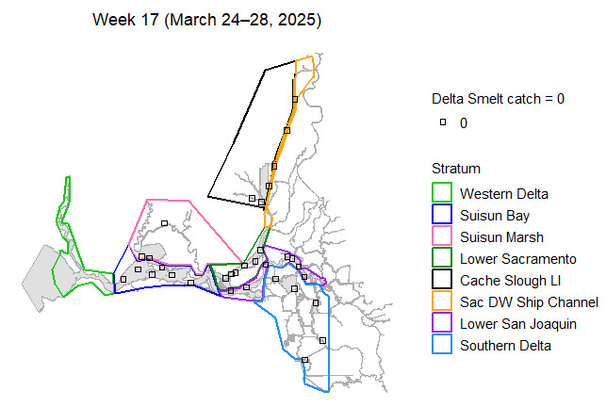
Figure 18: Map of total Delta Smelt catch by site in week 17.
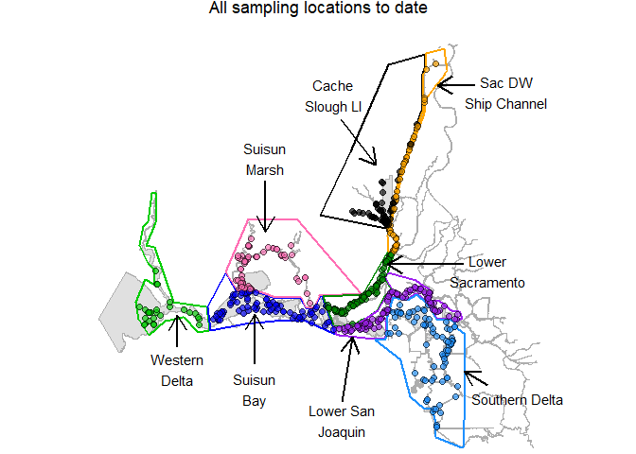
Figure 19: Map of all sampling sites in this phase.

Habitat Volume Estimates
Table 4: Estimates of water volume (cubic meters) between 0.5-m and 4.5-m depth, by stratum.
Stratum | Volume
Western Delta | 190,166,275
Suisun Bay | 285,840,678
Suisun Marsh | 76,278,718
Lower Sacramento | 88,162,170
Cache Slough LI | 33,420,492
Sac DW Ship Channel | 30,411,491
Lower San Joaquin | 122,096,565
Southern Delta | 136,731,814

References
Stevens D.L. and Olsen A.R. 2004. Spatially balanced sampling of natural resources. Journal of the American Statistical Association, 99(465):262–278.

